1.Project Title: Sports Hall Booking System by Service Portal

Team Members:
1.Gunde Akhila
2.Jalandhara Devi Kondeboina
3.Likitha Korumilli
4.Dasu Navya Sri
5.Fhiroz Khan Shaik

2. Project Overview
The Sports Hall Booking System is a custom application developed on the ServiceNow platform to simplify and automate the sports hall reservation process. The application allows users to manage sports hall details, create booking records, and prevent duplicate bookings for the same hall and time slot. It also includes an event-driven email notification configuration for booking reminders. A customized Sports Zone Service Portal was developed with an enhanced user interface to display sports hall information and provide a simple booking experience. The project demonstrates the use of ServiceNow components such as custom tables, Business Rules, Scheduled Jobs, Event Registry, Email Notifications, and Service Portal widgets to build an efficient booking management system.
2.1 Purpose
The main purpose of the Sports Hall Booking System is to provide an efficient and organized solution for managing sports hall reservations. The system replaces manual booking methods by storing all booking information in a centralized database and preventing duplicate reservations through server-side validation. It also demonstrates the practical implementation of ServiceNow application development by integrating automation, data management, and a user-friendly portal interface. The system helps improve booking accuracy, reduce manual effort, and simplify the overall management of sports facilities.
2.2 Features
The key features of the Sports Hall Booking System are:
- Custom Sports Hall and Sports Bookings tables for managing application data.
- Creation and management of sports hall booking records.
- Duplicate booking prevention using a Business Rule.
- Automated reminder event configured through the Event Registry.
- Email Notification configuration for booking reminder emails.
- Customized Sports Zone Service Portal with an improved user interface.
- Dynamic display of sports hall details using a custom Service Portal widget.
- Responsive user interface developed using HTML, CSS, JavaScript, and AngularJS.
- Automatic booking charge calculation on the Service Portal.
- Centralized management of sports hall booking information within the ServiceNow platform.

3. Technical Architecture
The Sports Hall Booking System is developed using the ServiceNow App Engine and follows a structured architecture consisting of the user interface, application logic, data layer, and notification services. The system uses the Service Portal as the front-end interface, where users can view sports hall details and access the booking page. The application logic is implemented using Business Rules, GlideRecord scripts, and Service Portal widgets to validate bookings, retrieve data, and manage booking operations.

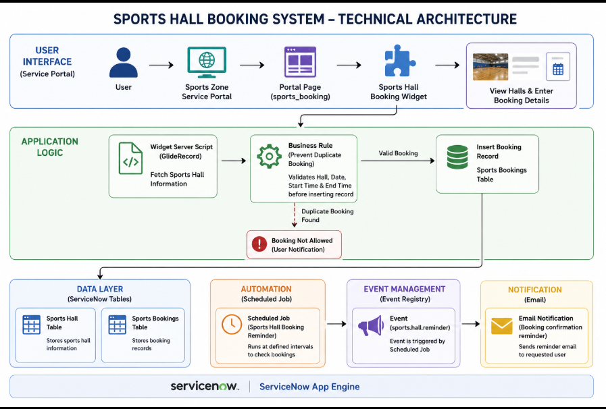

Technical Architecture Components
- Platform: ServiceNow App Engine
- User Interface: Service Portal (Sports Zone)
- Portal Page: Sports Booking (sports_booking)
- Custom Widget: Sports Hall Booking Widget
- Frontend Technologies: HTML, CSS, JavaScript, AngularJS
- Backend Scripting: GlideRecord, Business Rules (Server-side JavaScript)
- Database: Custom ServiceNow Tables
  - Sports Hall
  - Sports Bookings
- Automation: Scheduled Job
- Event Management: Event Registry (sports.hall.reminder)
- Notifications: Email Notification (Booking Confirmation Reminder)

System Workflow
- The user opens the Sports Zone Service Portal.
- The portal displays available sports halls using a custom widget.
- The user selects a sports hall and enters booking details.
- The Business Rule validates the booking to prevent duplicate reservations.
- If the booking is valid, the record is stored in the Sports Bookings table.
- The Scheduled Job triggers the registered event when required.
- The Event Registry activates the configured Email Notification to send booking reminders.
This architecture provides a centralized, reliable, and scalable solution for managing sports hall bookings while demonstrating the use of key ServiceNow development components.
──────────────────────────────────────────────────────────────────────────────────
4.Setup Instructions
The Sports Hall Booking System was developed and tested using the ServiceNow Personal Developer Instance (PDI). The following setup steps were performed before implementing the application.

4.1 Prerequisites
Before setting up the project, ensure the following requirements are available:
- ServiceNow Personal Developer Instance (PDI)
- System Administrator (admin) access
- Modern web browser (Google Chrome or Microsoft Edge)
- Stable internet connection
- Basic knowledge of the ServiceNow platform

4.2 Environment Setup
- Log in to the ServiceNow Personal Developer Instance.
- Create a new Scoped Application named Sports Hall Booking System.
- Create the required custom tables:
  - Sports Hall
  - Sports Bookings
- Configure the required table fields based on project requirements.
- Insert sample sports hall records for testing.
- Configure the Sports Zone Service Portal.
- Create the Sports Booking portal page.
- Develop and attach the custom Sports Hall Booking Widget to the portal page.
- Configure the Business Rule to prevent duplicate bookings.
- Create the Event Registry and Email Notification.
- Configure the Scheduled Job for booking reminder events.
- Test the application by creating booking records and verifying validations and notifications.

4.3 Technologies Used
Component | Technology
Platform | ServiceNow App Engine
Frontend | Service Portal
UI Development | HTML, CSS, AngularJS, JavaScript
Backend Logic | GlideRecord, Business Rules
Database | ServiceNow Custom Tables
Automation | Scheduled Job
Notification | Event Registry, Email Notification

4.4 Application Components
The project consists of the following ServiceNow components:
- Scoped Application
- Sports Hall Table
- Sports Bookings Table
- Business Rule
- Scheduled Job
- Event Registry
- Email Notification
- Service Portal
- Sports Booking Page
- Custom Service Portal Widget

4.5 Verification
After completing the setup, verify the following:
- Sports halls are displayed on the Service Portal.
- Booking records are successfully created.
- Duplicate bookings are prevented.
- Booking details are stored in the Sports Bookings table.
- Scheduled Job executes successfully.
- Event Registry triggers the configured Email Notification.

5.Folder Structure:
Sports-Hall-Booking-System/
│
├── Documentation/
│ └── Project_Report.pdf
│
├── ServicePortal/
│ ├── client_controller.js
│ ├── server_script.js
│ ├── sports_hall_booking_widget.css
│ └── sports_hall_booking_widget.html
│
└── README.md

6. Running the Application
To run the Sports Hall Booking System, follow these steps:
- Log in to the ServiceNow Developer Instance.
- Open the Sports Hall Booking System application.
- Ensure that the required Sports Hall records are available in the Sports Hall table.
- Open the Sports Booking Service Portal using the portal URL:
- https://<instance-name>.service-now.com/sp?id=sports_booking
- The portal displays all available sports halls with their details, including sport type, location, capacity, hourly charge, and availability status.
- Click the Book Now button for the desired sports hall.
- Enter the Booking Date, Start Time, and End Time.
- Click Calculate Charge to calculate the total booking cost.
- Click Submit Booking to create the booking request.
- If the selected hall is already booked for the same date and time, the system displays a duplicate booking validation message and prevents the booking.
- After a successful booking, the booking record is stored in the Sports Bookings table, email notifications are triggered, and reminder events are handled through the configured Event Registry and Scheduled Job.

7. API
The Sports Hall Booking System does not use any external REST APIs or third-party API integrations. The application is built entirely within the ServiceNow platform and uses its built-in server-side APIs for data processing and business logic.
Internal ServiceNow APIs Used
API | Purpose
GlideRecord | Used to retrieve, insert, and update records in the Sports Hall and Sports Bookings tables.
GlideSystem (gs) | Used for server-side operations such as retrieving the logged-in user and system functions.
Server Script API | Used to exchange data between the Service Portal widget and the ServiceNow database.

8. Authentication
The Sports Hall Booking System uses ServiceNow's built-in authentication mechanism to provide secure access to the application. Users must log in to the ServiceNow instance using valid credentials before accessing the application or the Service Portal.
Authentication and user management are handled entirely by the ServiceNow platform, ensuring that only authorized users can access application data and perform booking operations. The application also uses ServiceNow's role-based access control to protect records and system components.
Authentication Features
- ServiceNow username and password authentication.
- Secure login through the ServiceNow platform.
- Access restricted to authenticated users.
- Role-based access control for application resources.
- User identity managed by ServiceNow.
This authentication approach ensures secure access to the Sports Hall Booking System while leveraging the built-in security capabilities of the ServiceNow platform.

9. User Interface
The Sports Hall Booking System provides a simple, responsive, and user-friendly interface through the ServiceNow Service Portal. The portal was designed to allow users to easily browse available sports halls and initiate the booking process with minimal effort.
The home page displays sports hall information in a modern card-based layout. Each card presents important details such as the hall name, sport type, location, capacity, hourly charge, and availability status. Users can select a sports hall by clicking the Book Now button, which opens a booking form for entering the required booking details.
The interface was developed using HTML, CSS, JavaScript, and AngularJS within a custom Service Portal widget. Responsive styling, hover effects, and a clean layout were implemented to provide a professional user experience across different screen sizes.
User Interface Features
- Sports Zone Service Portal homepage.
- Dynamic display of sports hall details.
- Card-based layout for easy navigation.
- Booking form with date and time selection.
- Automatic booking charge calculation.
- Responsive design with modern styling.
- Simple and intuitive user interface.
- Clear display of hall availability and booking information.
Recommended Screenshots:
- Sports Zone Home Page
- Sports Hall Cards
- Booking Form
- Booking Success/Validation Screen

10. Testing Strategy
The Sports Hall Booking System was tested to ensure that all implemented functionalities work correctly and meet the project requirements. Testing focused on verifying data accuracy, booking validation, portal functionality, and notification configuration. Both backend and frontend components were tested using different input scenarios to ensure reliable system performance.
Testing Activities
- Verified the creation and retrieval of sports hall records.
- Tested the creation of sports booking records.
- Validated duplicate booking prevention using the Business Rule.
- Verified that sports hall details are displayed correctly on the Service Portal.
- Tested the Book Now functionality and booking form.
- Verified automatic booking charge calculation.
- Confirmed successful storage of booking records in the Sports Bookings table.
- Tested the Event Registry and Email Notification configuration.
- Verified the execution of the Scheduled Job for booking reminders.
- Checked the user interface for responsiveness and proper navigation.

Testing Summary

Test Case | Expected Result | Status
Display Sports Hall Details | Sports halls are displayed correctly on the portal | ✅ Passed
Create Booking | Booking record is created successfully | ✅ Passed
Duplicate Booking Validation | Duplicate bookings are prevented | ✅ Passed
Charge Calculation | Total booking charge is calculated correctly | ✅ Passed
Store Booking Record | Booking details are saved in the database | ✅ Passed
Event Registry | Reminder event is triggered successfully | ✅ Passed
Email Notification | Reminder email is configured and triggered correctly | ✅ Passed
User Interface | Portal loads and functions correctly | ✅ Passed

The testing results confirm that the Sports Hall Booking System performs as expected and satisfies the functional requirements defined for the project.

Demo:

Link : https://drive.google.com/file/d/1RZ6y06NdAicKM-61OeEmAZylY1mKXDoD/view?usp=sharing

Screenshots:

Home Page:
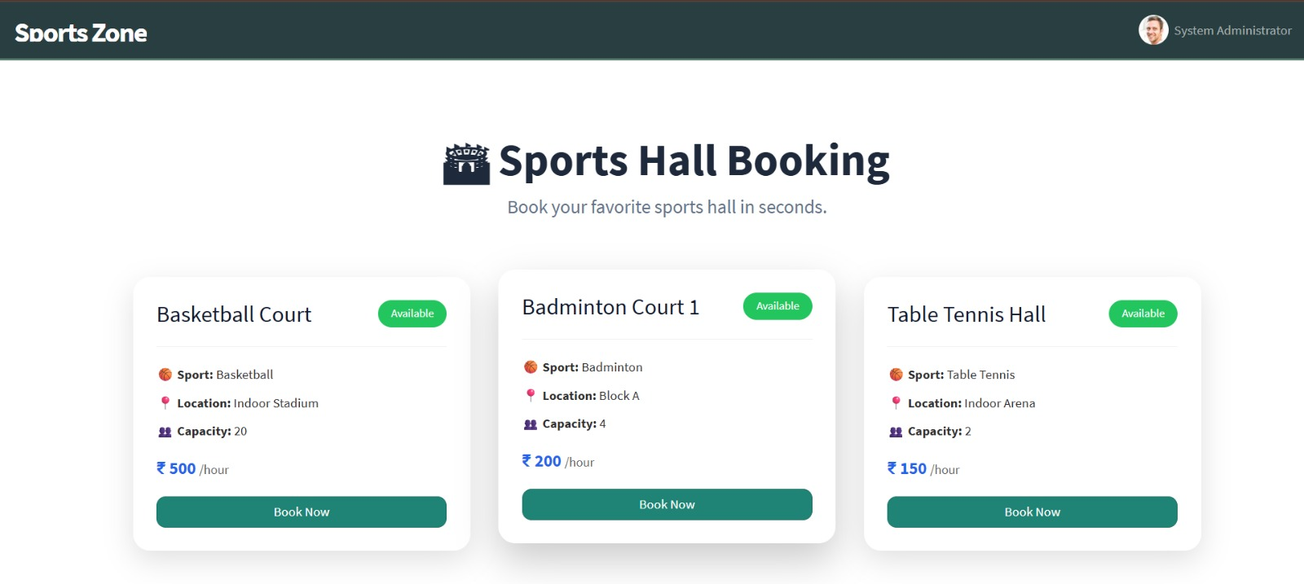
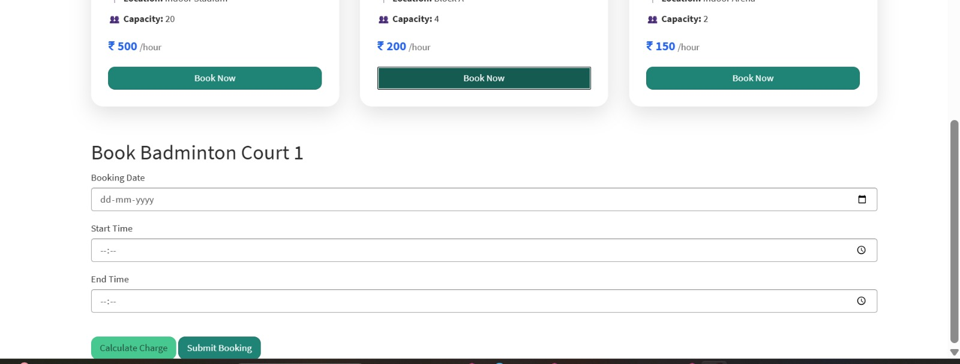

Application:

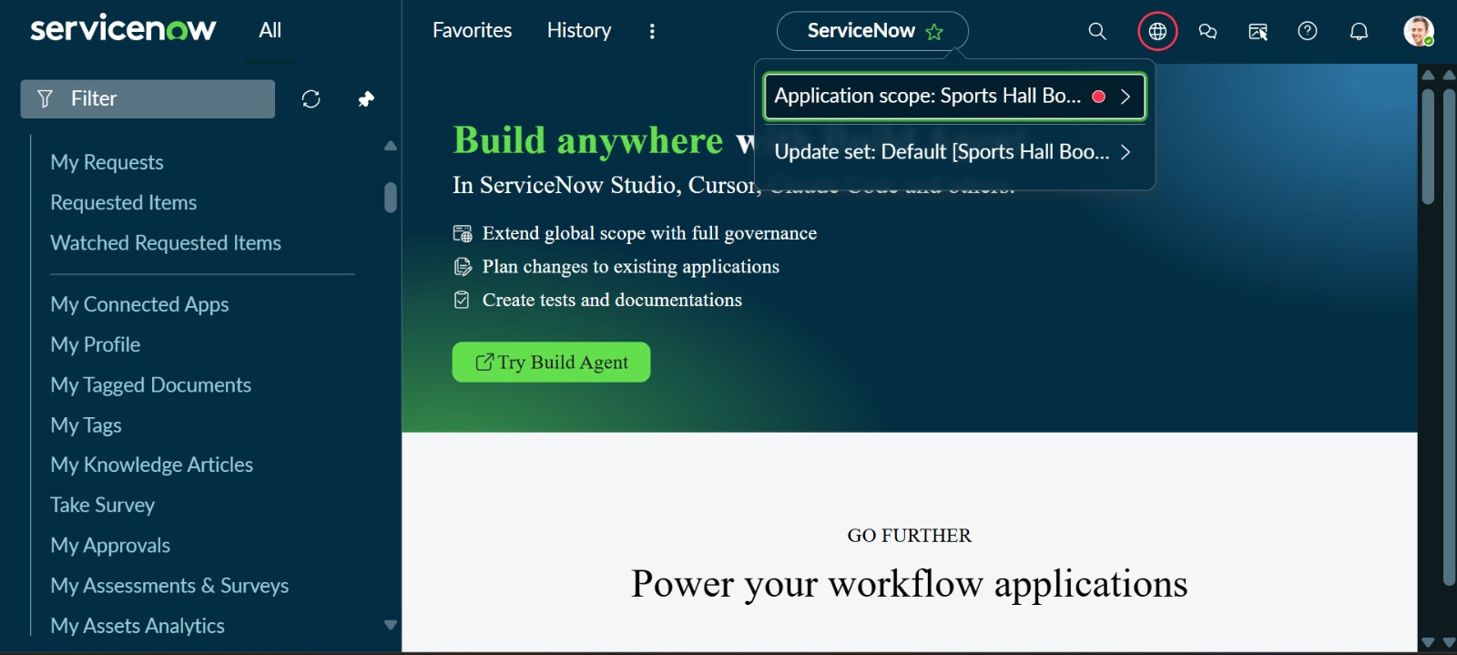

Sports Hall Booking Page:

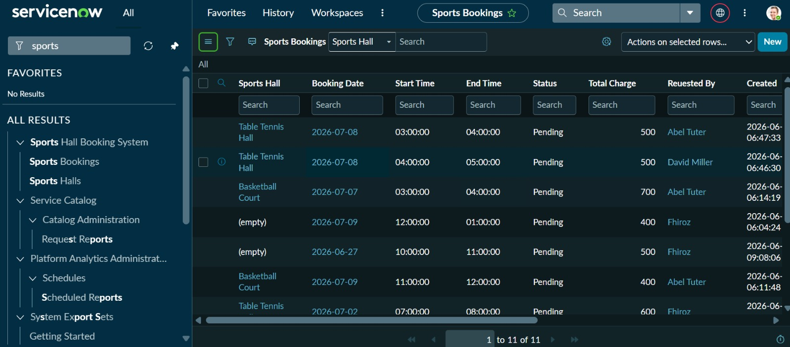

Booking Form:
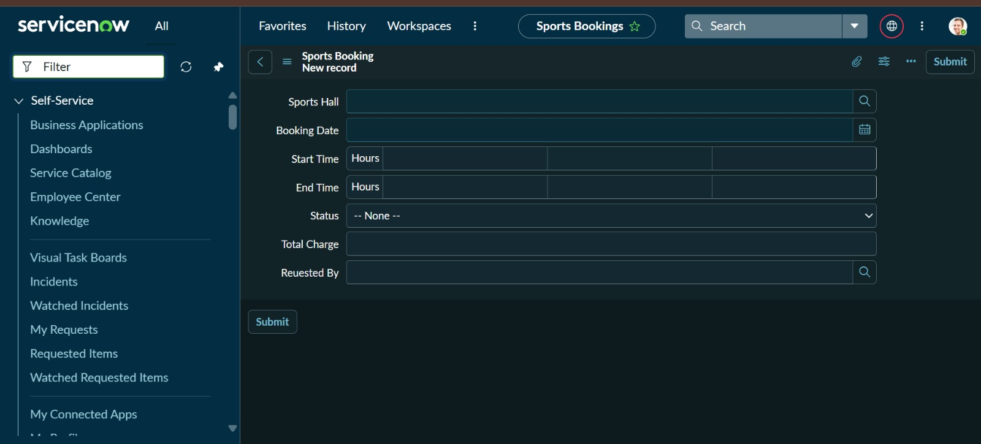

Duplicate Validation:

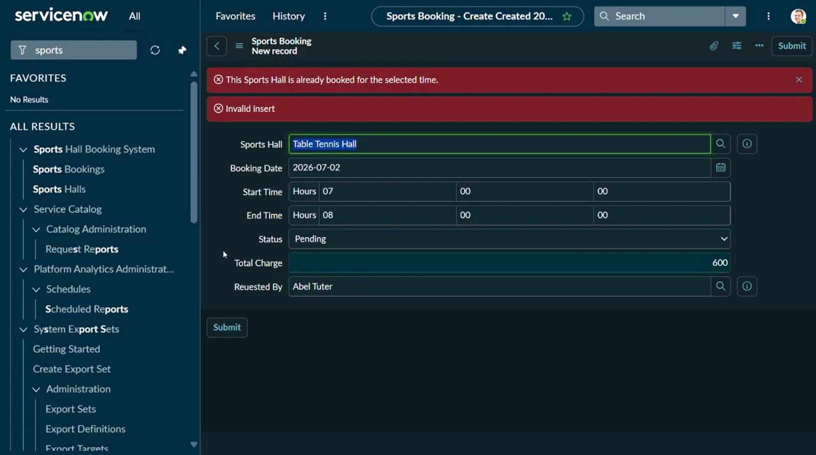

Email Notification:

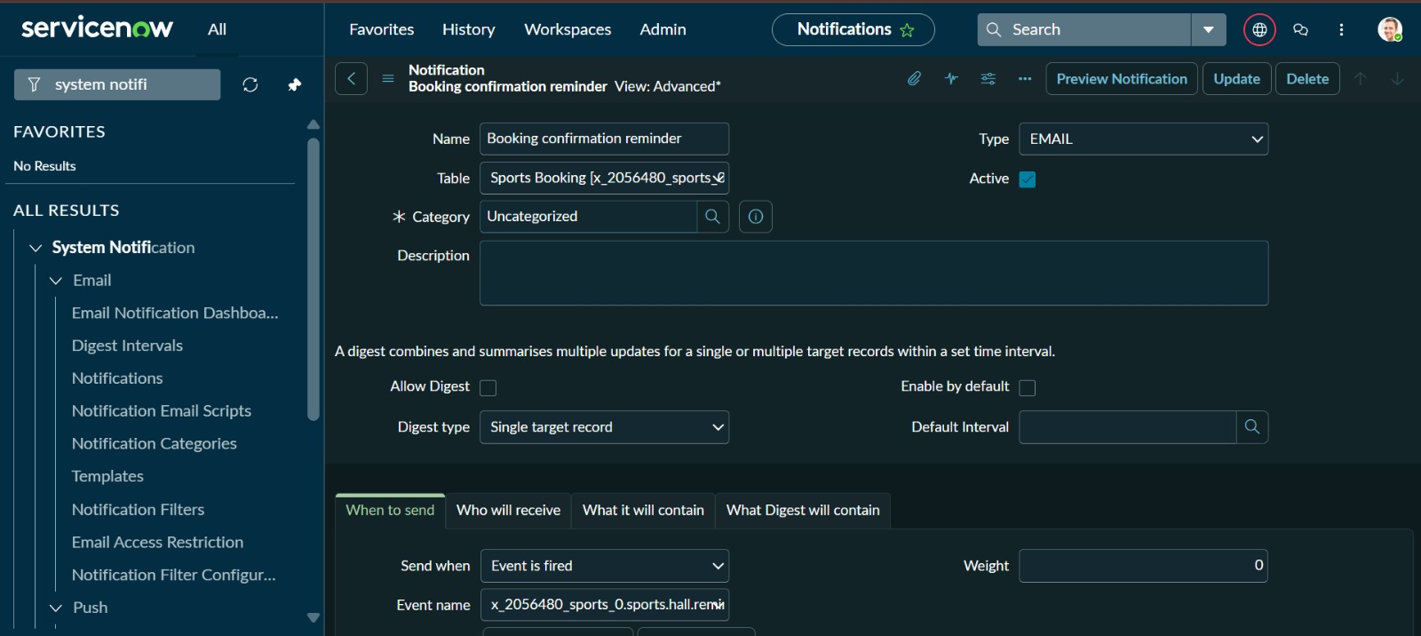

Event Registry:

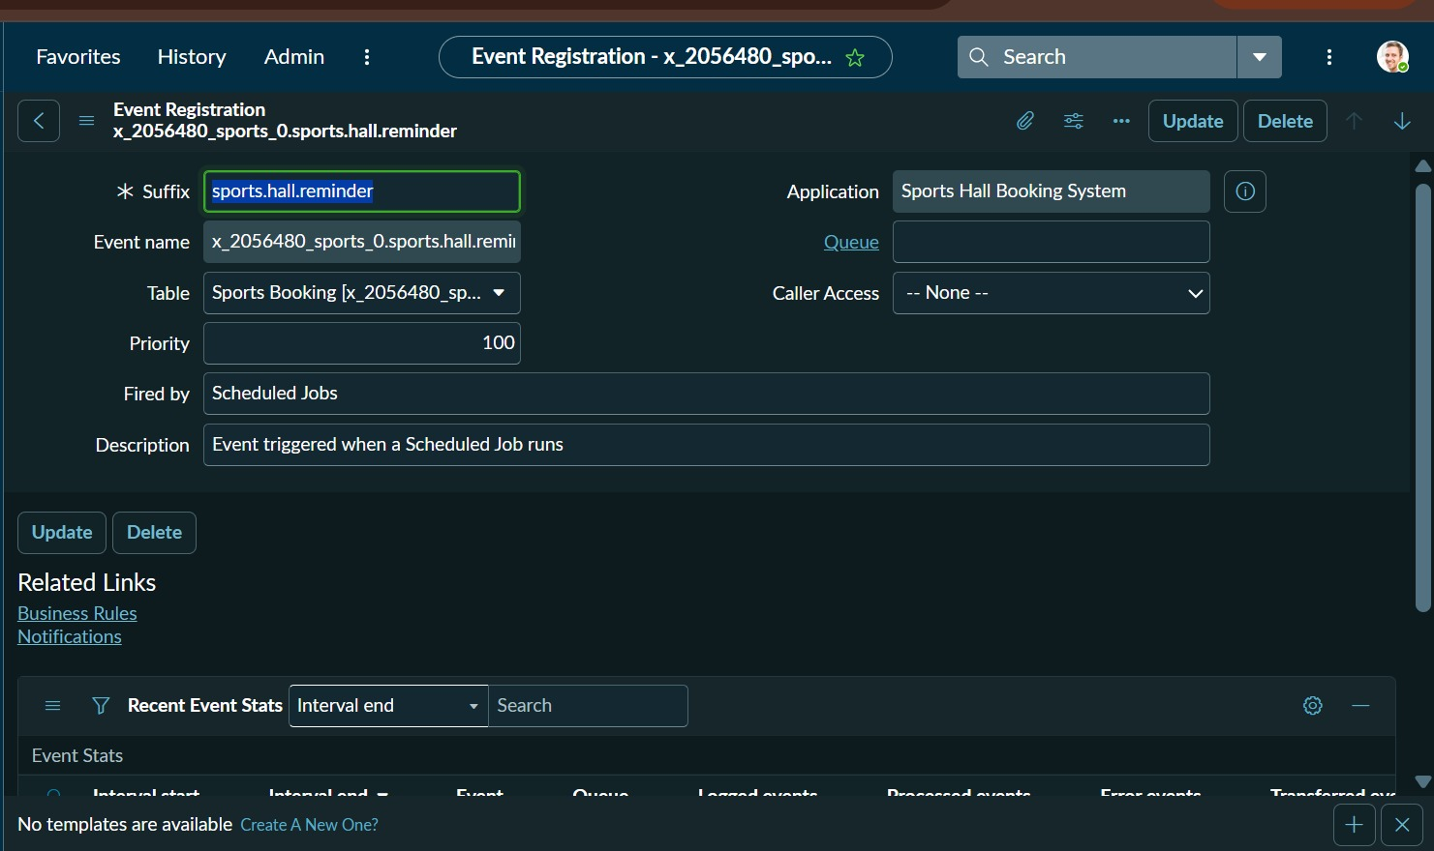

12. Known Issues
Although the Sports Hall Booking System meets the project requirements, a few limitations were observed during implementation:
- The system is currently designed for internal users within the ServiceNow environment and does not support public user registration.
- Sports hall availability is managed through the existing booking records, but advanced calendar-based slot visualization is not available.
- The application focuses on the core booking workflow and does not include payment processing or billing features.
- Booking notifications are limited to the features implemented in the project and do not include SMS or push notifications.
- Reports are limited to the information available in ServiceNow tables and do not include advanced analytical dashboards.
- The system has been tested in the development environment and may require additional testing before deployment to a production environment.
- The current implementation supports the project requirements but may require optimization for handling a large number of simultaneous booking requests.

13. Future Improvements
The Sports Hall Booking System can be enhanced further with the following features:
- Develop a dedicated admin dashboard with graphical booking statistics and utilization reports.
- Add a calendar view to display hall availability and upcoming bookings.
- Implement online payment integration for paid sports facilities.
- Introduce QR code or digital pass verification for booked halls.
- Add SMS and mobile push notifications for booking confirmations and reminders.
- Develop a mobile-friendly application for easier access across devices.
- Implement waitlist functionality when all slots are occupied.
- Add role-based enhancements for sports coordinators and facility managers.
- Integrate with institutional calendars and event management systems.
- Improve scalability and performance to support a larger number of users and multiple sports facilities.

